**Unit Seven Lab**

Directions: Complete each of the scripts below and submit them by the date specified in the assignment sheet and Blackboard. Submit **copies of your code** and **screenshots of the code running with each task**. Also, be sure to use the document, **Script Requirements as a guide** to writing good code. **Full credit will not be earned if you do not meet these script requirements.** **40 points**

**Note: Since we are running APIs on the NXOS switches in this lab, be sure to run the feature nxapi command from global configuration on each switch before attempting to send and API request.**

1. **Using the NXOS Sandbox to help generate code change an IP address on an interface. The create the following script:**
   1. **Using a function, print out show a IP interface brief (created on the week 5 exam).**

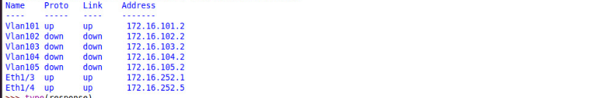

* 1. **Then in the main script, ask your user which interface they would like to change the address on. Verify that the interface exists in another function (compare the input to the interface name in the nested dictionary).**
  2. **If the interface exists, ask the user for a valid IP address and mask. In another function, verify that the IP address and mask are valid (i.e., a valid IP and subnet mask)**
  3. **If the address is valid, change the address in yet another function**
  4. **Finally, call the show ip interface brief function above to prove that the address has changed.**

1. **HINT: Be sure to change the IP address and interface name fields in the payload before making the call to change the IP address. Both intName and ipAddr are variables in my script (yours will be different). See below:**

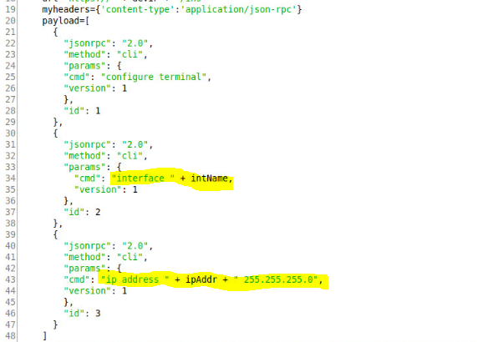

**Errors:**

**Wrong Interface**

**Wrong IP**

**Wrong Subnet**

**Wrong IP and Subnet**

